
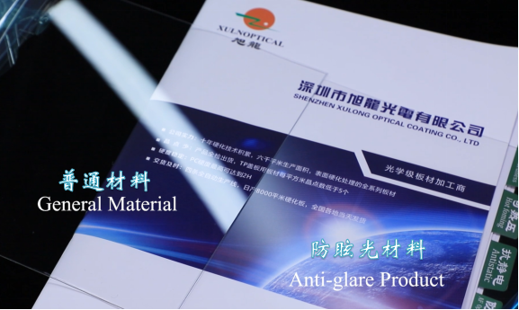
HMD(S)06-LC 防眩光PC优点防眩光、AF防指纹、抗冲击、韧性好, 可应用于对硬度要求较低的需要防反射的产品，如功能机镜片、小家电面板、防护眼镜、安防面板和电梯户外广告牌等PC anti glare board has the advantages of anti glare, AF anti fingerprint, anti impact and good toughness. It is mainly used in products with low hardness requirements, such as functional lens, small household appliance panel, protective glasses, security panel and elevator outdoor billboard.
HMD(S)06-LA 防眩光PMMA优点防眩光、AF防指纹、硬度高、钢性强，可应用于对表面硬度要求较高的需要防反射产品，如空调面板、医疗器械面板、智能家居面板和汽车充电桩面板等PMMA anti glare board has the advantages of anti glare, AF anti fingerprint, high hardness and strong rigidity. It is mainly used in products with high surface hardness requirements, such as air conditioning panel, medical device panel, smart home panel and automobile charging pile panel.
HMD(S)06-2L 防眩光板复合板优点防眩光、AF防指纹、硬度高且抗冲击性能强，可应用于对硬度抗冲击均有要求的需要防反射产品，例如手机电池盖、电子书触摸镜片及电池盖等 two-layer composite board anti glare board has the advantages of anti glare, AF anti fingerprint, high hardness and strong impact resistance. It is mainly used in products with requirements for hardness and impact resistance, such as mobile phone battery cover, e-book touch lens and battery cover.
HMD(S)06-3L 防眩光三层复合板优点防眩光、AF防指纹、低翘曲、钢性强，可应用于一些高端要求的需要防反射产品，例如车载仪表盘和中控面板等 Three layer composite board anti glare board has the advantages of low warpage, good flatness, anti glare, AF anti fingerprint and strong rigidity. It is mainly used in some high-end products, such as vehicle dashboard and central control panell.

材料型号  Plate type | 颜色  Color | 特征  Feature | 厚度（mm）  Thickness | 有效尺寸（mm)  Effective size
HMD(S)06-LC  AG防眩光PC | 雾面/磨砂  Fog / Frosting | 防刮花 /防眩光 /AF防指纹  Anti scratch/ Anti-Glare/AF | 0.175mm-4.0mm | 1120mm*1710mm
HMD(S)06-LA  AG防眩光PMMA | 雾面/磨砂  Fog / Frosting | 防刮花 /防眩光 /AF防指纹  Anti scratch/ Anti-Glare/AF | 0.5mm-4.0mm | 1130mm*1560mm  1130mm*1710mm
HMD(S)06-2L  AG防眩光复合板 | 雾面/磨砂  Fog / Frosting | 防刮花 /防眩光 /AF防指纹  Anti scratch/ Anti-Glare/AF | 0.25mm-2.0mm | 1130mm*1880mm
HMD(S)06-3L  AG防眩光三层复合板 | 雾面/磨砂  Fog / Frosting | 防刮花 /防眩光 /AF防指纹  Anti scratch/ Anti-Glare/AF | 0.65mm-2.0mm | 1130mm*1880mm
板材结构图
Structure diagram
PC、PMMA、PC+PMMA
PMMA+PC+PMMA
保护膜Protective film
AG防眩光涂层Anti-Glare coating layer
防刮花涂层Hard coating layer
颜色保护膜Protective film
基材Substrate

Typical Property Values

AG防眩光板材  AG Anti-Glare sheet |  |  |  |  |  | 测试方法  Test method
型号  Model | HMD(S)06-LC |  | HMD(S)06-LA | HMD(S)06-2L | HMD(S)06-3L | /
基材  Substrate | PC材质 | PMMA材质 |  | PC+PMMA材质 | PMMA+PC+PMMA材质 | /
厚度  Thickness | 0.175-4.0mm  ±0.05 | 0.4-4.0mm  ±0.05 |  | 0.25-2.0mm  ±0.05 | 0.65-2.0mm  ±0.05 | 千分尺  Micrometer
透光率  Transmittance | ≥90% | ≥90% |  | ≥90% | ≥90% | ASTMD1003
雾度  Haze | 8±2%  （雾度可定制1-80%） | 8±2%  （雾度可定制1-80%） |  | 8±2%  （雾度可定制1-80%） | 8±2%  （雾度可定制1-80%） | ISO14732
光泽度60°  Gloss 60° | 95±15 | 95±15 |  | 95±15 | 95±15 | 光泽仪  Glossmeter
粗糙度（Ra)  Roughness(Ra) | 0.06-0.09 | 0.06-0.09 |  | 0.06-0.09 | 0.06-0.09 | 粗糙度测试仪  Roughness tester
表面硬度  Pencil hardness | HB | 4H |  | PC:HB  PMMA：4H  0.5mm厚度以下PMMA面：2-3H | 4H | PC：500g,PMMA:750g 法码，三菱铅笔划痕  PC:500g,PMMA:750g Farmar, MITSUBISHI pencil scratch
耐磨性  Abrasion resistance | 外观无变化  No change in appearance | 外观无变化  No change in appearance |  | 外观无变化  No change in appearance | 外观无变化  No change in appearance | 绑无尘布，20mm*20mm，负重1kg，磨擦2000次  Tied dust-free cloth, 20mm*20mm, weight 1kg, friction 2000 times
水滴角  Water Drop angle | ≥105° | ≥105° |  | ≥105° | ≥105° | 水滴角测量仪  Water drop angle measuring instrument
燃烧性UL94  Combustibility | HB-V2 | HB |  | HB-V2 | HB-V2 | UL94
收缩率  Shrinkage rate | 0.2% | 0.3% |  | 0.2% | 0.2% | ASTM D1204
膜层附着性  Film adhesion | 5B | 5B |  | 5B | 5B | ASTM D3359
这些都是典型的属性,不用于规范的目的。如果最低可确认的属性是必需的,请联系我公司的业务为您服务。

These are typical properties and are not intended for specification purposes. If minimum certifiable properties are required, please contact my company's business to serve you.

